A3: Demo and Improved User Experience (UX) using Prototyping Tool

**Group 16:** Marco Ayuste, Dhruva Bhatt, Jessica Cruz, Tomoki Leung, Lucy Ye

**Link to Prototype (Figma):** <https://www.figma.com/file/RWOC4lSxDjmiQs4OrYi5g0/YouTube-MAIN?type=design&node-id=0%3A1&mode=design&t=D4zla4pU0q8rTtNo-1>

Prototype Link: <https://www.figma.com/file/RWOC4lSxDjmiQs4OrYi5g0/YouTube-MAIN?type=design&node-id=0%3A1&mode=design&t=D4zla4pU0q8rTtNo-1>

The purpose of this project is to redesign YouTube so that it can improve the overall usability of content viewers, and additionally, benefit content creators. The proposed design, as displayed through the Figma mid-fidelity prototype, is created via thorough evaluation of Jakob Nielsen’s usability heuristics for interaction design and Don Norman’s principles of design.

**Redesign Overview**

Improved usability was the main purpose of this redesign, however an accommodation for content creators is also considered. This means that this redesign focuses on how creators can be benefited, and hence be motivated to make videos.

Redesign Choice 1

The first redesign choice is influenced by the *Error Prevention* and *Recognition Rather Than Recall* heuristics. Video recovery from the user's previous watch history should be available to them as soon as they enter the homepage to prevent further actions and more clicks to get to their history. The change made has allowed the user's video history option to be seen on their homepage, in the case that the user has made a mistake of exiting a video they are currently watching. The history option is normally accessible after multiple clicks, which complicates navigation, but by keeping this option in the sidebar allows for easy access and does not crowd the homepage.

Redesign Choice 2

The second redesign choice is influenced by the *Flexibility and Efficiency of Use* heuristic. The user's subscriptions should be available as soon as possible, in the promotion of creators' content to be offered to the viewer (user) on the start-up homepage. The change that has been made allows all the user's channel subscriptions to be available on the homepage, for the user to access and scroll through their preferred content more efficiently.

Redesign Choice 3

The third redesign choice is influenced by the *Flexibility and Efficiency of Use* to allow the user to have their 'Watch Later' videos available to them as soon as they open the homepage. This change benefits the user efficiently that the series of clicks required to get to their 'Watch Later' playlist is reduced and allows the user to access their 'Watch Later' directly from their homepage, as desired from the user's initial response and goal of visiting YouTube. All videos from the user’s ‘Water Later’ playlist is indicated on the displayed homepage and labelled as From Watch Later’ to clarify to the user, in the case they have the desire to proceed or continue watching their saved videos from their previous session.

Redesign Choice 4

The fourth redesign choice has been made due to biased and unfair advantages of bigger content creators on YouTube. The change that removed the number of views on the user's homepage allows for users to discover smaller creators and grow their channels through interacting on the algorithm. Additionally, this design is influenced from the *Aesthetic and Minimalist Design heuristic*, so that excessive information is not presented on the main page.

Redesign Choice 5

The fifth redesign choice was followed by the *Flexibility and Efficiency of Use* heuristic that allows the user to have quicker access to the 'Add to Watch Later' action from their recommended videos on their homepage. This change has made a faster shortcut to the 'Add to Watch Later' function that removes it from the ellipse menu that appears when the cursor hovers just below the video. The 'Add to Watch Later' function was changed into a visible icon displayed directly onto the videos' thumbnails, for the user to immediately recognize the action. Additionally, when the Watch Later icon is clicked, the video is added to the watch later playlist, and when it is clicked again, the video is removed. This feature is crucial to increase efficiency of use since the user will not have to navigate across the page to click the undo button in the original design. This corresponds to the Mapping principle as it is human nature to click something twice to undo the effect. The watch later button also provides immediate Feedback, where the icon changes from a clock to a checkmark, rather than a delayed effect.

Redesign Choice 6

The sixth redesign choice is to improve upon the *Action Specification* and *Error Prevention* heuristic, which allows users the option to continue watching the videos they previously clicked out of. In cases where users accidentally click out of videos, the video users watched should be retained. Users should be able to quickly resolve their errors and expect some form of recovery from their mistakes. Adding the “continue watching” option on the side of the home page resolves users' inefficiency and adapts back into their videos without videos being reset.

Redesign Choice 7

The seventh redesign choice is reflected by the *Error Prevention* heuristic, where users are expected to verify before subscribing to channels. When subscribing to channels, users are not notified but are incented to subscribe before reflecting whether they want to subscribe or not. This causes the inefficiency of users misclick subscriptions, without notification users are not in knowledge of their actions. Allowing users to verify before subscription prevents unwanted subscriptions to channels, along with giving users the chance to consider their choices before deciding.

Redesign Choice 8

The eighth redesign choice is regarding the new live stream option available on the homepage. This option is placed on the side bar and allows for easier navigation to the live stream page. The live streams are then organized by genre, which helps organize the page and hence makes it easier to navigate. This redesign is influenced by the *Flexibility and Efficiency of Use* heuristic.

**Appendix 1**

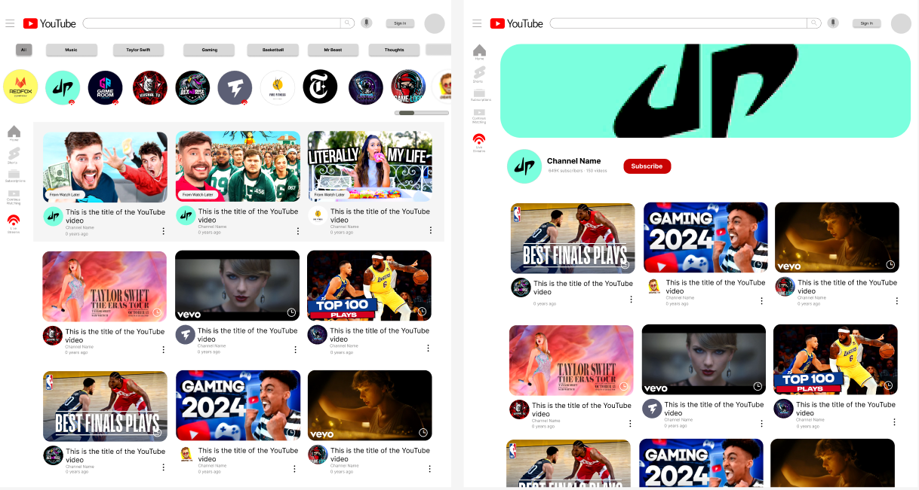

On the top of the homepage, users can view their subscribed channels. Using the scroll bar on the right, they can slide to view all their subscriptions. When clicking their subscription icon, it leads them to the channel’s homepage.

**Appendix 2**

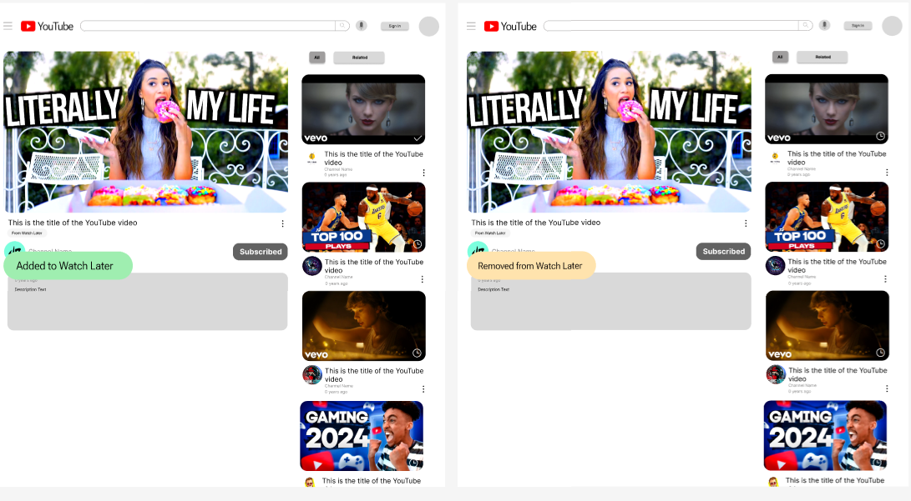

When users add videos to their watch later playlist, they will be presented with an icon notifying them that they have either added or removed a video from their playlist.

**Appendix 3**

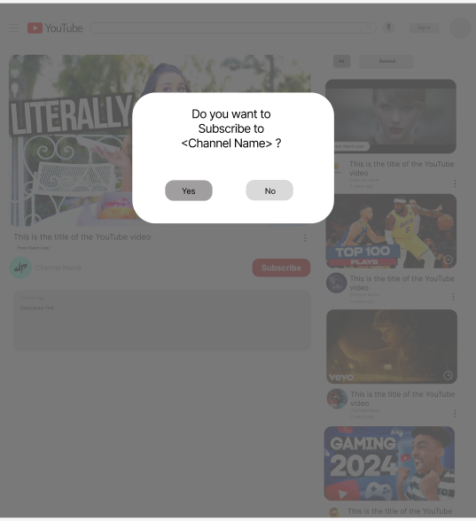

When clicking the subscription button, users are presented with a notification confirming their choice of subscription. Users are to select “yes” or “no” regarding their choices in finalising subscriptions.

**Appendix 4**

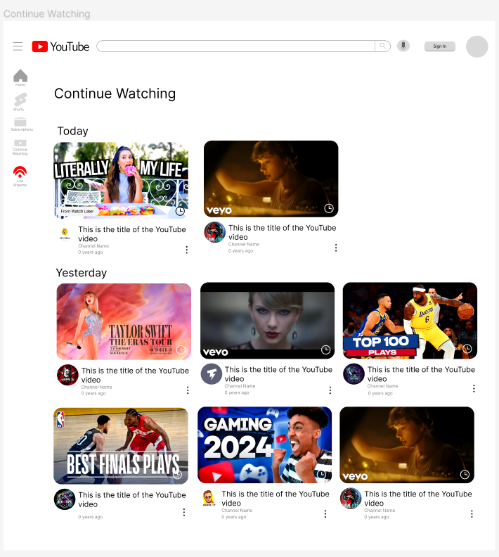

On the left bar there are 5 icons, labelling “home”, “shorts”, “subscriptions”, “continue watching” and “live streams” from top to bottom. When clicking on the continue watching tab, users are presented with the *Continue Watching* page. This Continue Watching page is thoughtfully designed to offer a seamless viewing experience, where users can immediately pick up where they left off across any device. The layout prioritizes user convenience, displaying videos in a clean, organized manner, with clear thumbnails, video titles, and progress bars indicating how much of the video has already been watched. This feature is particularly beneficial for users who often switch between devices or those who have to interrupt their viewing sessions, providing a straightforward way to dive back into their content without the need to search or scroll through their watch history.

**Appendix 5**

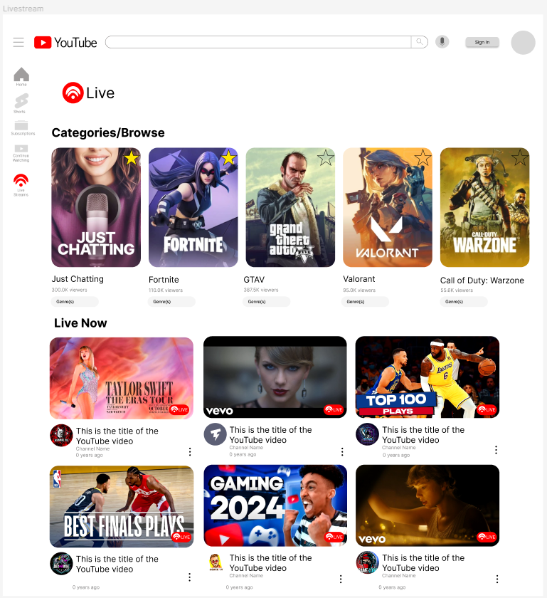

Our redesigned YouTube live streaming interface is presented to address navigational challenges and enhance the discoverability of live content, positioning YouTube as a competitive platform for live broadcasts. Key features include the integration of a prominent "Live" section on the homepage, alongside existing "Shorts" and "Subscriptions" sections, and a restructured livestreaming page with a robust browsing feature and expanded categories for a tailored viewing experience. Users can personalize their experience by favouriting categories, ensuring their preferred content is readily accessible. This redesign aims to streamline user experience, facilitating ease of access to live streams, and fostering a more intuitive and engaging environment for both viewers and influencers, potentially making YouTube a more attractive platform for live streaming activities.

**References**

YouTube. (n.d.). Retrieved February 2024, from <https://www.youtube.com/>

Twitch. (n.d.). Retrieved February 2024, from <https://www.twitch.tv/>